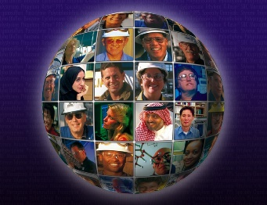
What is the Public Sphere?
Imagine a stage where actors are performing a play. Now imagine that everyone in society is watching this same play. Afterward, everyone in society can have similar discussions: Was the play any good? Did they cast the right actor in the lead role? Wasn’t the second scene in the third act hilarious? There is a whole stage that we are all watching. There are topics we all pay attention to, issues we all have opinions about, and policies that affect all our lives. The public sphere is a place where society discusses the issues that affect everyone. It links us all together as one large community.
Where is the Public Sphere?
Discussions in the public sphere exist at the local, national, and global levels all at the same time. On any given day, you might talk to a friend about the new skate park in your town, to your teacher about whether the state will change the graduation requirements next year, to your uncle about whether the U.S. should drill for oil off its coasts, or to a neighbor about the war against terrorism. All these issues exist in the public sphere, but on different levels. Someone who lives on the other side of the country probably isn’t talking about your new skate park, but they are talking about how the U.S. can gain energy independence. People in England probably aren’t talking about where the U.S. should drill for oil, but they’re probably worried about terrorism.
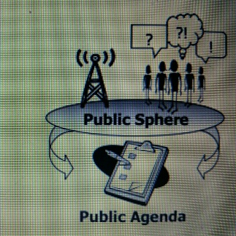
The Public Agenda
Discussions that take place in the public sphere give rise to the public agenda. An agenda is like a to-do list. Your personal agenda might include things like find a summer job, study for a test, or bring your “C” in history up to an “A.” The public agenda is a to-do list of issues that much of the public agrees are a priority. The public agenda might include things like clean up after a major natural disaster, solve the problems with our health care system, or decide who should be the next president.
Who Sets the Public Agenda?
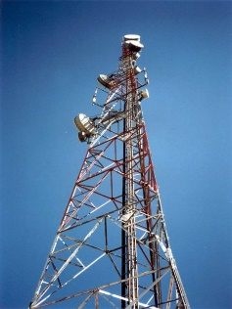
The issues on the public agenda depend on what is being discussed in the public sphere. But who decides what the public will discuss? Sometimes nobody decides, as with events like elections that occur on a regular schedule. Everyone knows when the election is going to happen, so people start talking about it. Similarly, large disasters don’t need any help getting attention. When planes slam into high-rise buildings in New York or a tsunami kills thousands of people in Japan, word spreads around the globe almost immediately. Issues people face in everyday life, such as drug abuse or expensive health care, also end up in the public sphere simply because so many people are personally affected by the problem.

But other issues are too distant or too specialized to get attention on their own. People starving in a far-off country, a new law that affects certain types of businesses, a species quietly going extinct in a disappearing ecosystem… Many important issues like these would never reach the public sphere if people did not hear about them in the news.
Public Spotlight
Sometimes public attention focuses on a person or event that does not require public action. When a celebrity marries or a team wins the Super Bowl, everyone may be talking about it, but there’s nothing to put on the public agenda. The celebrity or team is simply in the public spotlight. Even so, the public spotlight can call attention to issues. A celebrity who dies of a drug overdose may focus attention on the issue of drug abuse, which is always on the public agenda. Celebrities also use their fame to bring public attention to specialized issues that they care about.
Figure 1: Singer Beyoncé uses her celebrity to call attention to hunger in America

Public Opinion
Once people start paying attention to issues, they usually start forming an opinion about them. Public opinion is the view that a significant part of the public has about an issue. Public opinion is measured by polls, which are surveys that ask people what they think. When you hear things like “Two-thirds of Americans oppose…” or “A majority of Americans believe…” you are hearing the results of public opinion polls. It is important to remember that no poll actually surveys every single person in America. Polls take a sample, anywhere from a few hundred to a few thousand people, who are “representative” of the nation as a whole.
Public Policy and the Public Sphere
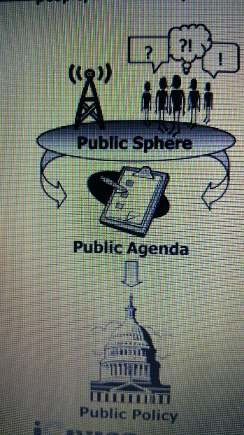
Public policy is the stand the government takes on an issue. The government’s stand on an issue affects the laws it passes and the actions it takes. But how does the government decide where to stand? One influence is the public agenda. If a huge proportion of society is talking about an issue, the government is likely to pay attention and do something about that issue. What, exactly, will the government do? That depends partly on public opinion. Remember that our government is made up of people who represent us. Those people, your senators and representatives, listen to what the public thinks. If a senator learns that three quarters of the voters in her district are against something, the senator will probably work against it on their behalf. If polls show most Americans favor something, Congress may feel bold enough to pass a law favoring that thing, or the president may take action to promote it. This does not mean the government is a slave to public opinion polls. Public policy is influenced by many factors, but in a country where voters decide who gets to be in government and who doesn’t, the public sphere can have a big impact on government.

