What is “The Media?”
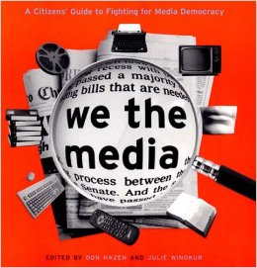
The word media means different things depending on how it is used. Media is the plural form of the word medium. A medium is a method of communicating information, entertainment, or other messages. Television is one popular medium. Radio, the internet, and cell phones are all examples of commonly used media. The term mass media refers to methods of communicating with large numbers of people. A lot of media exists purely for entertainment, such as movies and television sitcoms. But when you hear the phrase “the media,” usually it is referring to the sources of our news and information about current events. Paying attention to the media is how we stay informed about what’s going on in the world around us and what our government is doing.
The Media as Gatekeeper
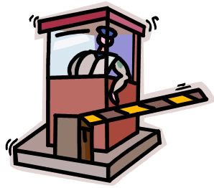
A gatekeeper stands guard at a gate and decides who gets to pass through and who doesn’t. In its role as gatekeeper, the media decides which stories and issues are important enough to receive public attention—and which aren’t. As a citizen, it is important for you to realize there are many serious events and issues you will never hear about on the evening news. Each news outlet has its own criteria for deciding which stories get through the gate and into the public eye. To understand why, you need to understand two things: the media is a business, and the media is almost always biased.
Gatekeeper: “B” is for Business
Most people get their news from television, radio, or a newspaper (either print or online). With the exception of PBS, the Public Broadcasting System, most are commercial or for-profit sources. They make money by selling time or space to advertisers. But advertisers won’t pay for ads nobody will see, so for-profit media must make the news as exciting as possible to attract lots of viewers. But let’s face it: News programs are not always as exciting as, say, action films. In order to survive in today’s culture, television news must keep things short, fast paced, and exciting. On-the-hour radio news is even shorter. Stories most likely to get through the gate are those that are the most gripping (ever wonder why the “news” is full of car crashes and house fires?) or that affect the most number of people. If a story can’t be told in a quick, 15-second sound bite, it’s likely to be left outside the gate.
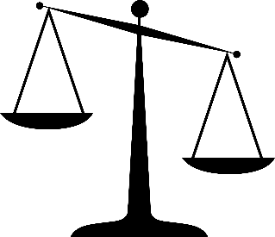
Gatekeeper: “B” is for Biased
Biased means favoring one view over another. As a human being, it is impossible to be completely unbiased even if you try. The media is made up of human beings; therefore, even when media outlets try to be unbiased, they’re not always successful. Bias may cause the media to open the gate to some stories instead of others or to report stories in a way that is weighted toward one side. There are many causes of bias. The most common among media sources is being more politically liberal (leaning toward the Democrats) or conservative (leaning toward the Republicans).
The Media as Agenda-Setter
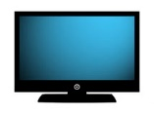
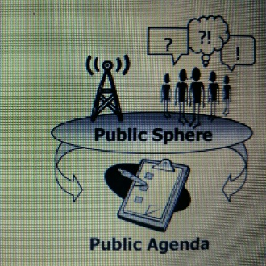
Because of its role as gatekeeper, the media is largely responsible for deciding what issues society discusses in the public sphere. That means the media also determines which issues are on the public agenda, which is the to-do list of issues the public agrees are a priority. An issue won’t get on the public agenda unless it is being discussed in the public sphere, and it won’t be discussed in the public sphere if nobody has heard about it.
Public Agenda: Fix healthcare More solar power Lower taxes
The media’s role as agenda-setter is controversial. Some people don’t think for-profit corporations should set our public agenda. They worry that many important issues will never get public attention. Some issues just aren’t exciting enough to compete with entertainment. Others are too complex to fit into a short sound bite. Although the public decides which issues to care about, the media only tells the public about a few of the issues that exist. Therefore, people worry that the public does not really have much of a choice about what issues are important. People also worry that a biased media influences the public agenda toward one way of thinking over another.
The Media as Watchdog
A real watchdog stands as a guard and barks loudly to alert the owner if there is something wrong. In its role as watchdog, the media keeps watch on the government and others in power. It speaks out to alert the public if something happens that shouldn’t. Local news stations often have a segment in which they investigate problems for people. Entire, hour-long news shows are devoted to exposés, which are stories designed to expose wrongdoing. Government officials who engage in bad behavior know they will be on every news show and newspaper in the country if they are caught. Although a watchdog will bark when there is something wrong, most of the time the watchdog just watches. Thanks to the media, we live in a world where we can turn on the television and watch our government in action at any given moment. Stations such as C-SPAN broadcast activity directly from the floor of Congress for everyone to see. Simply reporting information is playing watchdog, too. Without the media, we would not know what is happening behind closed doors.
The Media’s Audience: You
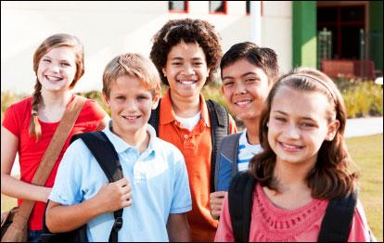
A watchdog doesn’t do any good if nobody is paying attention. The public sphere and the public agenda both depend on the same thing— the public, which is made up of people like you. If the media reported an event and nobody watched or responded, it would have no influence at all. In the same way, the public influences the media because the media can’t function without peoples’ attention. How people respond to the media’s reporting can affect which stories get through the gate.

