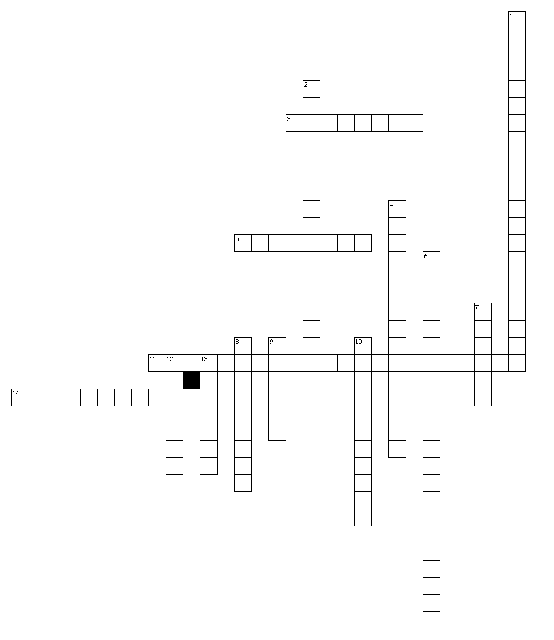

**Civics/Ch. 9: Judicial Branch**

**Crossword #1**

**Rappaport**

**Name: ______________________________________________**

**Period: ____________________**

**Across**

3. parties to a lawsuit

5. assumed to be true

11. either the federal or state court may try someone accused of committing a crime that breaks both state and federal law

14. the authority to hear and decide a case

**Down**

1. the authority to review the fairness of a case appealed from a lower court

2. the authority to hear cases for the first time

4. our federal courts exist alongside 50 separate state courts

6. only they have the authority to hear the cases

7. an official decision that settles a case and helps establish the meaning of the law

8. can be used as the basis for a decision in later, similar cases

9. the right to hold an office once a person is confirmed

10. introductory

12. offers a detailed explanation of the legal thinking behind the court's decision

13. approval

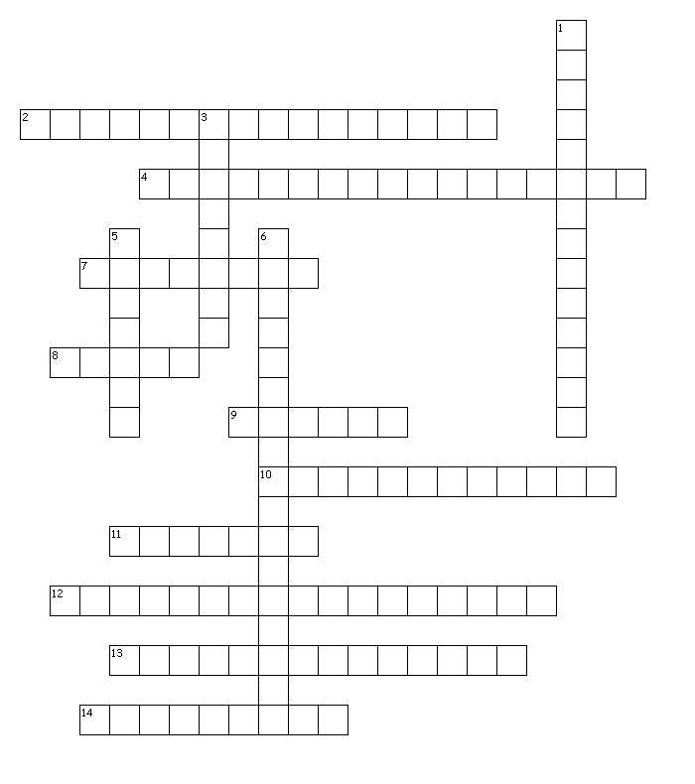

**Civics/Ch. 9: Judicial Branch Crossword #2 Rappaport**

**Name: ______________________________________________ Period: ____________________**

**Across**

2. directs a lower court to send its records on a case to the Supreme Court for review

4. statement by a justice who disagrees with the majority opinion, presenting his or her own opinion

7. is a court order that requires a person to appear in court

8. written document that explains one side's position on a case

9. calendar of cases to be heard

10. using earlier judicial rulings as a basis for deciding a case

11. written in their first form

12. statement by a justice who votes with the majority, but for different reasons than the others

13. follows the Constitution 14. to object to a decision or outcome

**Down**

1. means that the Court can review any federal, state, or local law or action to see whether it goes against the Constitution

3. the workload of cases in a period of time

5. legally cancel

6. a Supreme Court ruling on a case in which all judges agree on the ruling