Lesson 1 History of Political Parties
Theodore Roosevelt (1858–1919)
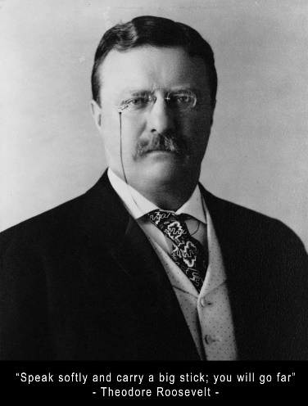
Theodore Roosevelt served his country with vigor. The twenty-sixth president of the United States led the country from 1901 until 1909 and was an outdoors enthusiast who lived what he called “the strenuous life.” Roosevelt would later use his strength and determination to lead the Bull Moose Party to a historic second-place finish in the 1912 Presidential election.
A frail child born into a prominent New York family, Roosevelt worked hard to overcome his physical weakness, revealing a level of determination that would mark his entire life. Roosevelt served on the U.S. Civil Service Commission, was president of New York’s Board of Police Commissioners, and acted as Assistant Secretary of the Navy before making his name in the Spanish-American War.
A Political Career Begins
Roosevelt returned to the United States a hero, and he was soon elected governor of New York. Roosevelt became vice president under William McKinley in a Republican victory in the election of 1900. McKinley was assassinated just months after the election, thrusting Roosevelt into the presidency. At the age of 42, Roosevelt was the youngest person ever to have held the office.
Roosevelt became such a popular leader that he was later elected to a second term in office. His administration was considered extremely progressive, with Roosevelt championing workers’ rights and supporting laws regulating big business. A dedicated conservationist, Roosevelt also created an extensive system of national parks throughout the United States in 1905, preserving 194 million acres of public lands.
Bull Moose Party
After serving two terms as president, Roosevelt supported his friend, William Howard Taft, for the presidency. However, once in office, Taft alienated the progressive members of the Republican Party by not appointing progressives to his cabinet and by supporting high tariffs. Because of this, Roosevelt challenged him and decided to run for a third term as president. Primary voters selected Roosevelt as the Republican candidate, but party leaders nominated Taft. Roosevelt and his supporters split from the Republicans to form the Progressive Party, popularly called the Bull Moose Party. This split contributed to the election of the Democratic candidate, Woodrow Wilson. However, the Progressive Party won widespread support, and Roosevelt received more votes than Taft. The 1912 election marked the only time in U.S. history that a third-party candidate finished in second place.
Directions: Answer the questions below. Use the back of this paper if you need more room.
- Reporting: In what leadership roles did Theodore Roosevelt serve early in his life? _________________________________________ ____________________________________________________________________________________________________________
- Retelling: In your own words, tell how Roosevelt first became president. ________________________________________________ ____________________________________________________________________________________________________________
- Explaining: How did Roosevelt show his interest in conservation of natural resources? ______________________________________ ________________________________________________________________________________________________________________________________________________________________________________________________________________________
- Explaining: Why did Roosevelt and his supporters form the Progressive Party? ____________________________________________ ________________________________________________________________________________________________________________________________________________________________________________________________________________________
- Critical Thinking: Interpreting – What does the example of the Progressive Party indicate about the power of third parties? ____________________________________________________________________________________________________________ ________________________________________________________________________________________________________________________________________________________________________________________________________________________

