Bank Item Number |  | G.C.1.3.L1
Benchmark |  | SS.7.C.1.3
Cognitive Complexity |  | L
Item |  | Which document addressed colonial concerns about English policies?
A | * | Declaration of Independence
B |  | Mayflower Compact
C |  | U.S. Constitution
D |  | Bill of Rights

Bank Item Number |  | G.C.1.3.M1
Benchmark |  | SS.7.C.1.3
Cognitive Complexity |  | M
Item |  | The stamp below is from the front page of a 1765 newspaper.  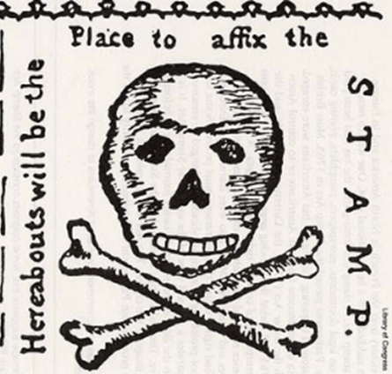  Source: Library of Congress  What was the significance of the stamp on the newspaper?
A |  | It demonstrated that Parliament ignored the colonists’ media communications.
B |  | It demonstrated that Parliament controlled the colonists’ press outlets.
C | * | It represented the colonists’ opposition to English tax policies.
D |  | It represented the colonists’ fulfillment of English tax policies.

Bank Item Number |  | G.C.1.3.M2
Benchmark |  | SS.7.C.1.3
Cognitive Complexity |  | M
Item |  | The political cartoon below was created by Benjamin Franklin in1754.  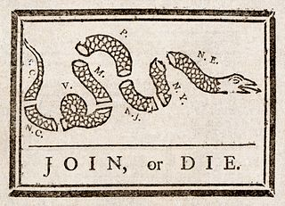  Source: Library of Congress  Which action did colonists use this cartoon to support?
A | * | Declaring independence from the British monarchy.
B |  | Declaring loyalty to the British monarchy.
C |  | Dissolving colonial legislatures.
D |  | Dissolving colonial charters.

Bank Item Number |  | G.C.1.3.M3
Benchmark |  | SS.7.C.1.3
Cognitive Complexity |  | M
Item |  | The quotes below are from historical documents.  “For imposing Taxes on us without our Consent”  “All bills for raising Revenue shall originate in the House of Representatives…”  Source: Declaration of Independence  Source: Article I Section 7 U.S. Constitution  What is the relationship between these concepts?
A |  | Both declare to the world why the colonists wanted freedom from England.
B |  | Both represent actions taken by the colonists to enforce English policies.
C | * | Both are in response to English policies imposed upon the colonists.
D |  | Both are responses by England to the actions of the colonists.

Bank Item Number |  | G.C.1.3.H1
Benchmark |  | SS.7.C.1.3
Cognitive Complexity |  | H
Item |  | Why did Parliament eventually repeal the Stamp Act, which taxed goods such as newspapers and playing cards?
A |  | The colonists established a blockade against British goods.
B |  | The colonists were able to produce their own goods.
C |  | The colonists started destroying British goods.
D | * | The colonists began boycotting British goods.

