Bank Item Number |  | G.C.1.6.L1
Benchmark |  | SS.7.C.1.6
Cognitive Complexity |  | L
Item |  | Which part of the U.S. Constitution states the six purposes of government?
A |  | Bill of Rights
B |  | Article IV
C | * | Preamble
D |  | Article I

Bank Item Number |  | G.C.1.6.M1
Benchmark |  | SS.7.C.1.6
Cognitive Complexity |  | M
Item |  | The statement below was made by President Lyndon B. Johnson during an address to the nation on March 31, 1968.  I shall not seek, and I will not accept, the nomination of my party for  another term as your President.  Source: Lyndon B. Johnson Presidential Library  Which intention of the Preamble is reflected in the statement?
A |  | Government holds frequent elections.
B | * | Government exists to serve the people.
C |  | Government promotes the general welfare.
D |  | Government provides for the common defense.

Bank Item Number |  | G.C.1.6.M2
Benchmark |  | SS.7.C.1.6
Cognitive Complexity |  | M
Item |  | Why did the Framers require that the U.S. House of Representatives have the sole power to introduce tax bills?
A |  | Laws are easier to debate and pass in the U.S. House of Representatives.
B | * | Members of the U.S. House of Representatives are directly elected by the people.
C |  | Elections are more frequent and expensive for the U.S. House of Representatives.
D |  | Members of the U.S. House of Representatives are required to have legal experience.

Bank Item Number |  | G.C.1.6.M3
Benchmark |  | SS.7.C.1.6
Cognitive Complexity |  | M
Item |  | This newspaper headline describes an event in U.S. history.  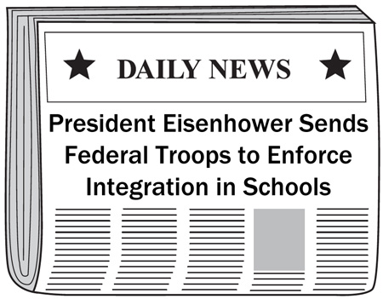  Which government purpose identified in the Preamble is reflected in the headline?
A | * | ensure domestic tranquility
B |  | promote the general welfare
C |  | secure the blessings of liberty
D |  | provide for the common defense

Bank Item Number |  | G.C.1.6.H1
Benchmark |  | SS.7.C.1.6
Cognitive Complexity |  | H
Item |  | The statement below is from a historical document.  We the People of the United States... do ordain and establish this Constitution for the United States of America.  Source: Library of Congress  How is this statement reflected in the modern American political system?
A | * | Voters elect Congress members.
B |  | The Electoral College elects Congress.
C |  | Congress enforces policies.
D |  | The president enacts policies.

