Bank Item Number |  | G.C.2.11.L1
Benchmark |  | SS.7.C.2.11
Cognitive Complexity |  | L
Item |  | Which option presents a clear point of view?
A | * | bias
B |  | metaphor
C |  | propaganda
D |  | symbolism

Bank Item Number |  | G.C.2.11.M1
Benchmark |  | SS.7.C.2.11
Cognitive Complexity |  | M
Item |  | Which source would give the most accurate information about the views held by an incumbent running for Congress?
A |  | special interest group ratings of that Congress member
B |  | a television commercial sponsored by a political party
C | * | the voting record of the candidate while in Congress
D |  | flyers sent through the mail by the candidate

Bank Item Number |  | G.C.2.11.M2
Benchmark |  | SS.7.C.2.11
Cognitive Complexity |  | M
Item |  | The passage below is from a U.S. Supreme Court decision.  The Federal Communications Commission (FCC) has for many years imposed …a “fairness doctrine,” requiring that public issues be presented by broadcasters and that each side of those issues be given fair coverage.  Source: Red Lion Broadcasting Co., Inc. v. Federal Communications Commission (1969)  Based on the passage, what is a goal of the FCC regulation?
A | * | to limit bias in political communication
B |  | to promote bias in political communication
C |  | to limit symbolism in political communication
D |  | to promote symbolism in political communication

Bank Item Number |  | G.C.2.11.M3
Benchmark |  | SS.7.C.2.11
Cognitive Complexity |  | M
Item |  | Below is a statement made by Secretary of Defense Donald Rumsfeld.  …the news media seem to want to carry the negative.  Source: Interview with Jerry Agar, KMBX News Radio 980, June 27, 2005.  What type of political communication is being referenced in the statement?
A | * | bias
B |  | persuasion
C |  | propaganda
D |  | symbolism

Bank Item Number |  | G.C.2.11.H1
Benchmark |  | SS.7.C.2.11
Cognitive Complexity |  | H
Item |  | The poster below was placed in public buildings, businesses and schools by a civil rights group.  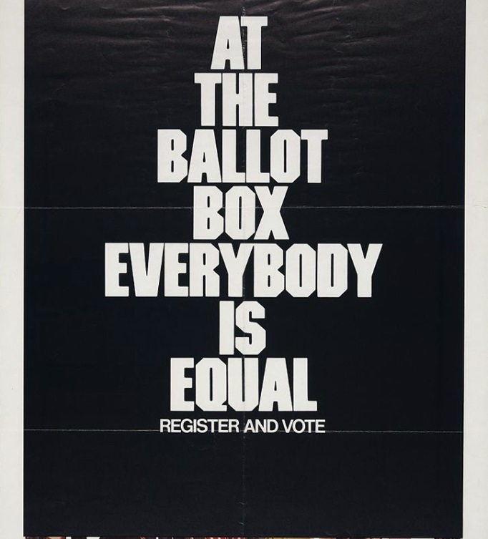  What is a long term policy goal of the interest group?
A |  | electing candidates
B |  | regulating elections
C | * | improving citizens’ lives
D |  | influencing political appointments

