Bank Item Number |  | G.C.2.12.L1
Benchmark |  | SS.7.C.2.12
Cognitive Complexity |  | L
Item |  | Who would a citizen contact about a problem with city roads?
A |  | the county commissioner
B |  | the president
C |  | the governor
D | * | the mayor

Bank Item Number |  | G.C.2.12.M1
Benchmark |  | SS.7.C.2.12
Cognitive Complexity |  | M
Item |  | Shrimp and seafood industries in Florida are concerned about the freshwater supply from Georgia. If the freshwater supply is reduced, Florida’s shrimp and seafood industries could be harmed. Who is responsible for resolving this dispute?
A |  | federal legislative branch
B | * | federal executive branch
C |  | state legislatures
D |  | state judiciary

Bank Item Number |  | G.C.2.12.M2
Benchmark |  | SS.7.C.2.12
Cognitive Complexity |  | M
Item |  | The newspaper headline below describes a community problem.  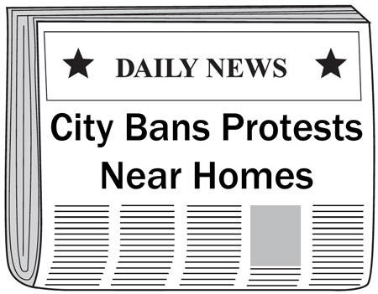  What problem was the ordinance meant to address?
A |  | concerns about local businesses
B |  | threats to public education
C |  | concerns about parking
D | * | threats to public safety

Bank Item Number |  | G.C.2.12.M3
Benchmark |  | SS.7.C.2.12
Cognitive Complexity |  | M
Item |  | Why are canned food drives held?
A | * | to help private community groups support those in need
B |  | to help city administrators fulfill their responsibilities
C |  | to help county officials meet their obligations
D |  | to help state agencies distribute benefits

Bank Item Number |  | G.C.2.12.H1
Benchmark |  | SS.7.C.2.12
Cognitive Complexity |  | H
Item |  | The statements below are from a conversation about a public policy issue.  ---------------------------  Peggy: People who receive state unemployment benefits should be required to perform community service.  Jeff: I disagree. People who are unemployed need the time to look for work.  ---------------------------  What public policy solution would Peggy and Jeff likely support?
A |  | increased background checks
B |  | increased support payments
C | * | expanded training programs
D |  | expanded private assistance

