Bank Item Number |  | G.C.3.13.L1
Benchmark |  | SS.7.C.3.13
Cognitive Complexity |  | L
Item |  | Which part of the Florida Constitution protects individual rights?
A | * | Declaration of Rights
B |  | Bill of Rights
C |  | Amendments
D |  | Preamble

Bank Item Number |  | G.C.3.13.M1
Benchmark |  | SS.7.C.3.13
Cognitive Complexity |  | M
Item |  | Which statement describes a similarity between the Florida Constitution and the U.S. Constitution?
A |  | neither protects individual rights
B | * | both include an amendment process
C |  | neither provides for a chief executive
D |  | both include a nine member Supreme Court

Bank Item Number |  | G.C.3.13.M2
Benchmark |  | SS.7.C.3.13
Cognitive Complexity |  | M
Item |  | Which statement describes a similarity between the Florida Constitution and the U.S. Constitution?
A | * | both include a Preamble
B |  | both include seven articles
C |  | both require legislative term limits
D |  | both require native born chief executives

Bank Item Number |  | G.C.3.13.M3
Benchmark |  | SS.7.C.3.13
Cognitive Complexity |  | M
Item |  | The table below shows constitutional elements.  ?  Amendments  Articles  Preamble  Which title completes this table?
A |  | Florida and County Government
B | * | Florida and U.S. Government
C |  | City and County Government
D |  | City and U.S. Government

Bank Item Number |  | G.C.3.13.H1
Benchmark |  | SS.7.C.3.13
Cognitive Complexity |  | H
Item |  | The headline below describes an action by citizens.  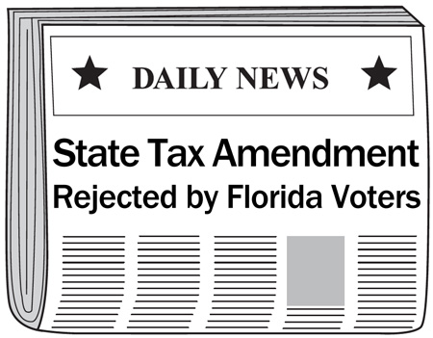  What conclusion can be drawn from the headline?
A |  | Citizens can be involved in policy making through their representatives.
B | * | Citizens can be directly involved in policy making.
C |  | Only elected officials may change constitutions.
D |  | Only elected officials make policy.

