Bank Item Number |  | G.C.3.2.L1
Benchmark |  | SS.7.C.3.2
Cognitive Complexity |  | L
Item |  | Where is power concentrated in a unitary system of government?
A | * | central government
B |  | state government
C |  | dictator
D |  | military

Bank Item Number |  | G.C.3.2.M1
Benchmark |  | SS.7.C.3.2
Cognitive Complexity |  | M
Item |  | What system of government was in place after the United States adopted the U.S. Constitution?
A |  | confederal
B | * | federal
C |  | oligarchy
D |  | parliamentary

Bank Item Number |  | G.C.3.2.M2
Benchmark |  | SS.7.C.3.2
Cognitive Complexity |  | M
Item |  | The table below describes a type of government.  ?  Executive Elected by the legislature  Legislature Elected by the people  Which title completes the table?
A | * | Parliamentary Government
B |  | Confederal Government
C |  | Federal Government
D |  | Unitary Government

Bank Item Number |  | G.C.3.2.M3
Benchmark |  | SS.7.C.3.2
Cognitive Complexity |  | M
Item |  | The table below describes a type of government.  ?  Executive Elected by the people  Legislature Elected by the people  Which title completes the table?
A |  | Parliamentary Government
B |  | Confederal Government
C | * | Federal Government
D |  | Unitary Government

Bank Item Number |  | G.C.3.2.H1
Benchmark |  | SS.7.C.3.2
Cognitive Complexity |  | H
Item |  | The newspaper headline below describes a historical event.  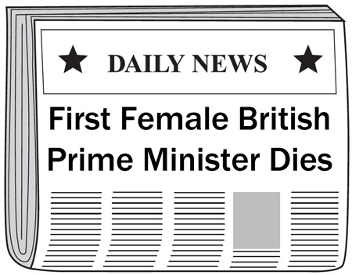  What long term impact does this headline reflect?
A |  | protection of equal property rights
B |  | expansion of the right to privacy
C |  | protection of due process rights
D | * | expansion of the right to vote

