Bank Item Number |  | G.C.3.5.L1
Benchmark |  | SS.7.C.3.5
Cognitive Complexity |  | L
Item |  | Which government institution may vote on constitutional amendments?
A |  | bureaucracy
B |  | executive
C |  | judicial
D | * | legislative

Bank Item Number |  | G.C.3.5.M1
Benchmark |  | SS.7.C.3.5
Cognitive Complexity |  | M
Item |  | The newspaper headline below describes an event in U.S. history.  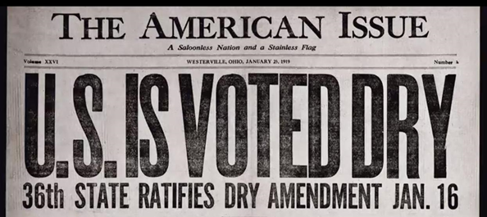  Source: Anti-Saloon League Museum  Based on the headline, what happened before the event presented in the image?
A | * | Two-thirds of each house of Congress voted to support the amendment.
B |  | The president rejected the amendment after Congress voted to support it.
C |  | Three-fourths of each house of Congress voted to support the amendment.
D |  | The president forwarded the amendment to the states after Congress voted to support it.

Bank Item Number |  | G.C.3.5.M2
Benchmark |  | SS.7.C.3.5
Cognitive Complexity |  | M
Item |  | The timeline below provides details about a constitutional amendment.  1917: Amendment prohibiting alcohol manufacture, sale or transportation voted on by Congress.  1919: 18th Amendment prohibiting alcohol manufacture, sale or transportation is ratified by the states.  1933: 21st Amendment reversing the 18th Amendment is added to the U.S. Constitution.  According to the timeline, what happened between 1919 and 1933?
A | * | The 21st Amendment was approved by state ratifying conventions.
B |  | The 21st Amendment was overturned by the U.S. Supreme Court.
C |  | The 21st Amendment was vetoed by the president.
D |  | The 21st Amendment was vetoed by Congress.

Bank Item Number |  | G.C.3.5.M3
Benchmark |  | SS.7.C.3.5
Cognitive Complexity |  | M
Item |  | The passage below was written by U.S. Senator Barack Obama in his 2006 book, The Audacity of Hope.  I see democracy as a conversation to be had…It provides us with a framework and rules, but all its machinery are designed to force us into a conversation.  Based on the passage, which statement about the amendment process would Senator Obama support?
A |  | The ratification process allows the president to reflect public views.
B |  | The ratification process allows governors to reflect public views.
C | * | The U.S. Constitution is difficult to amend.
D |  | The U.S. Constitution is easy to amend.

Bank Item Number |  | G.C.3.5.H1
Benchmark |  | SS.7.C.3.5
Cognitive Complexity |  | H
Item |  | The passage below is from an 1848 speech by Elizabeth Cady Stanton.  In the United States of America women [are] unrepresented in this government—our rights and interests wholly overlooked.  Source: Public Domain  Based on the passage, which action in the modern political system would Elizabeth Cady Stanton support?
A | * | amending the U.S. Constitution to extend suffrage
B |  | amending the U.S. Constitution to guarantee due process
C |  | Congress enacting a law limiting freedom of speech rights
D |  | Congress enacting a law limiting freedom of association rights

