Bank Item Number |  | G.C.3.7.L1
Benchmark |  | SS.7.C.3.7
Cognitive Complexity |  | L
Item |  | How did the passage of the Voting Rights of 1965 impact political participation?
A |  | All persons who passed a literacy test could now vote.
B |  | All children of foreign citizens could now vote.
C | * | All African-Americans could now vote.
D |  | All women could now vote.

Bank Item Number |  | G.C.3.7.M1
Benchmark |  | SS.7.C.3.7
Cognitive Complexity |  | M
Item |  | The passage below describes a U.S. Supreme Court decision.  In 1940, the Texas Democratic Party refused to give an African-American man a ballot to select candidates to run for Congress and governor.  In finding this action unconstitutional, the U.S. Supreme Court stated “…this Court is not constrained to follow a previous decision which…, involves the application of a constitutional principle, rather than an interpretation of the Constitution to evolve the principle itself.”  Source: Smith v. Allwright (1944)  According to the passage, what did this U.S. Supreme Court decision illustrate?
A |  | The U.S. Supreme Court expanded voting rights through Voting Rights Act interpretation.
B | * | The U.S. Supreme Court expanded voting rights through amendment interpretation.
C |  | The U.S. Supreme Court limited voting rights through amendment interpretation.
D |  | The U.S. Supreme Court limited voting rights through the Voting Rights Act.

Bank Item Number |  | G.C.3.7.M2
Benchmark |  | SS.7.C.3.7
Cognitive Complexity |  | M
Item |  | How are 14th Amendment due process protections related to the Civil Rights Act of 1968?
A |  | Congress may not enact discriminatory housing statutes.
B |  | Congress may not enact discriminatory employment policies.
C | * | State legislatures may not enact discriminatory housing statutes.
D |  | State legislatures may not enact discriminatory employment policies.

Bank Item Number |  | G.C.3.7.M3
Benchmark |  | SS.7.C.3.7
Cognitive Complexity |  | M
Item |  | The photograph below illustrates an event in U.S. history.  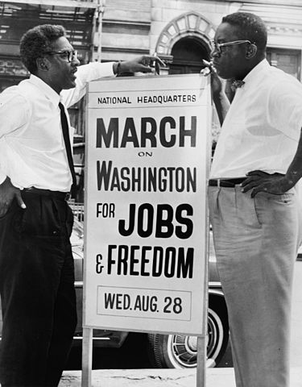  Source: Library of Congress  What was Congress’ response to the social movement symbolized in the photograph?
A |  | decreased commerce opportunities
B | * | increased economic opportunities
C |  | increased religious opportunities
D |  | decreased military opportunities

Bank Item Number |  | G.C.3.7.H1
Benchmark |  | SS.7.C.3.7
Cognitive Complexity |  | H
Item |  | The graph below describes voter registration in Florida among blacks and whites.  Source: Adapted from Florida Division of Elections  Based on the graph, what conclusion can be drawn about voter turnout in Florida since the Voting Rights Act of 1965 was passed?
A |  | Voter turnout among blacks has decreased.
B |  | Voter turnout among whites has decreased.
C | * | Voter turnout among blacks has increased.
D |  | Voter turnout among whites has increased.

