Bank Item Number |  | G.C.4.1.L1
Benchmark |  | SS.7.C.4.1
Cognitive Complexity |  | L
Item |  | What is a responsibility of the U.S. Senate in foreign policy?
A |  | nominating ambassadors
B |  | introducing tax bills
C |  | negotiating treaties
D | * | ratifying treaties

Bank Item Number |  | G.C.4.1.M1
Benchmark |  | SS.7.C.4.1
Cognitive Complexity |  | M
Item |  | Which action is an example of a domestic policy decision?
A |  | The Senate votes to ratify a treaty.
B |  | The president nominates an ambassador.
C | * | Congress votes to increase the income tax.
D |  | The president asks Congress to declare war.

Bank Item Number |  | G.C.4.1.M2
Benchmark |  | SS.7.C.4.1
Cognitive Complexity |  | M
Item |  | The statement below was made by Secretary of State Hillary Clinton during a January 23, 2013 Senate hearing.  It has been one of the great honors of my life to lead the men and women of the State Department … nearly 70,000 serving here in Washington, more than 270 posts around the world. They get up and get to work every day, often in difficult and dangerous circumstances, because they believe, as we believe, the United States is the most extraordinary force for peace and progress the world has ever known.  Source: U.S. Department of State  Based on the statement, which is a goal of U.S. policy?
A | * | diplomatic alliances
B |  | homeland security
C |  | citizen protection
D |  | avoiding conflict

Bank Item Number |  | G.C.4.1.M3
Benchmark |  | SS.7.C.4.1
Cognitive Complexity |  | M
Item |  | The political cartoon below illustrates a foreign policy issue.  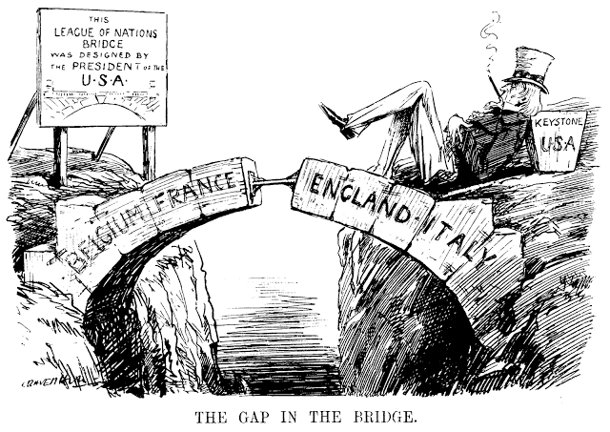  Source: Public Domain  What issue is illustrated in the cartoon?
A |  | The Cabinet did not ratify a treaty.
B |  | The President did not ratify a treaty.
C | * | The U.S. Senate did not ratify a treaty.
D |  | The Secretary of State did not ratify a treaty.

Bank Item Number |  | G.C.4.1.H1
Benchmark |  | SS.7.C.4.1
Cognitive Complexity |  | H
Item |  | Below is a graph about high school graduation rates in the United States.  Source: Adapted from National Center for Education Statistics  Which long term domestic policy goal is reflected in the graph?
A | * | career preparation
B |  | physical fitness
C |  | racial equality
D |  | public safety

